**Name : Tejaswini Anil Kamble**

**Email: teju000kamble@gmail.com**

**Assignment : 18/06/2022**

**Task**

**Q. Imagine a remote control with buttons(invoker) that can control various electronics devices(Receivers) such as TVs or lights. Each button press sends a command (Concreate Command) to the respective device to perform actions like turning ON / OFF or changing channels.**

**Use Command Design paatern and impelemt it.**

**Solution : Source Code**

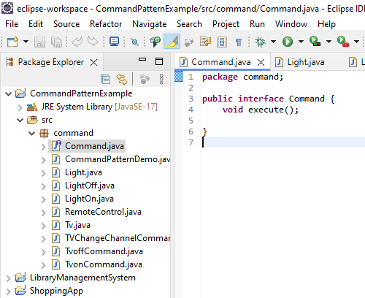

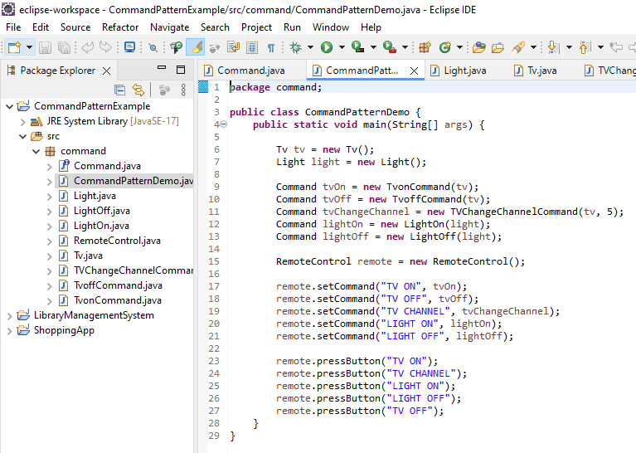

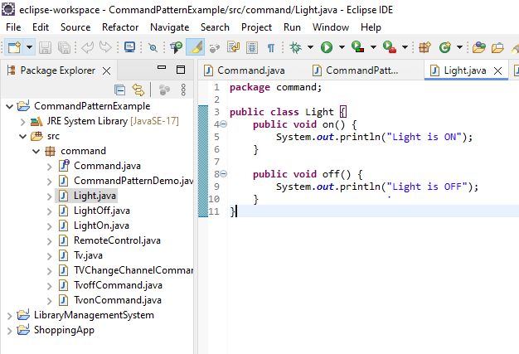

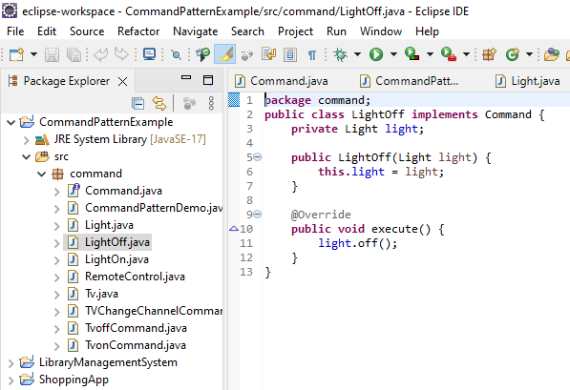

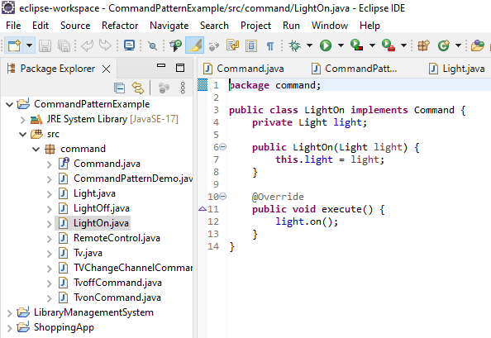

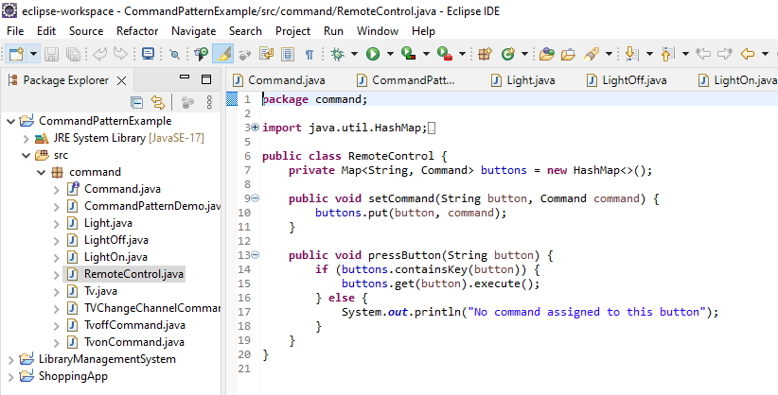

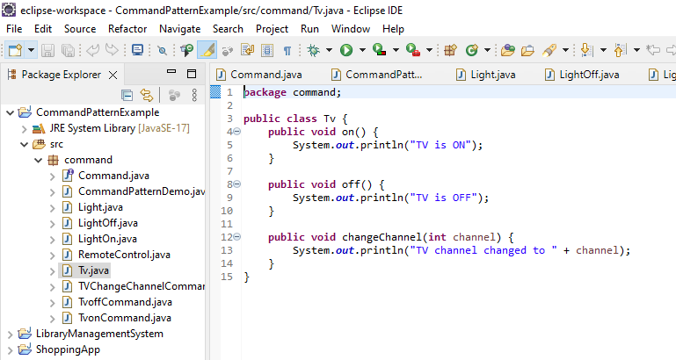

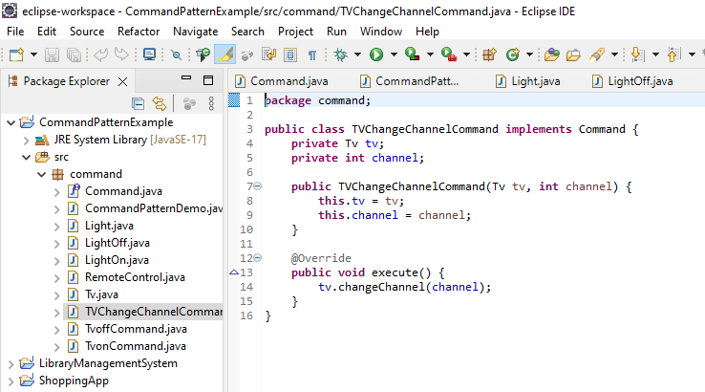

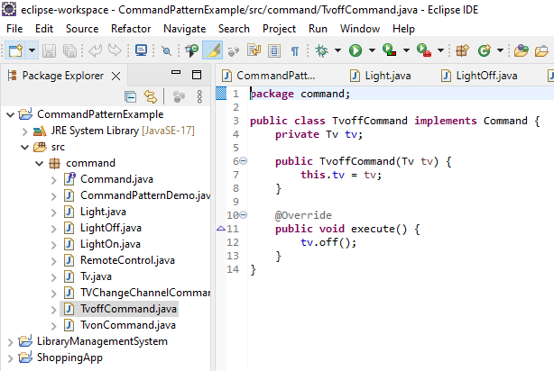

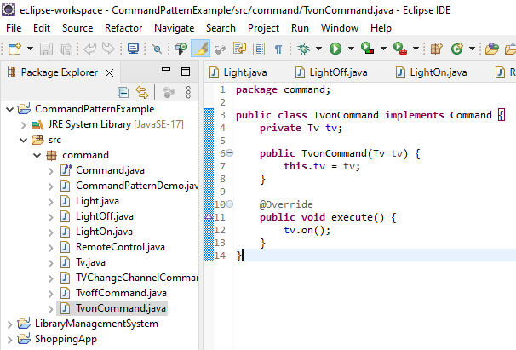

**Output:**

